Prof. Dr. Hartmut Lehmann
Academic Vice-Director of the Leibniz Institute for East and Southeast European Studies
Head of Economics Department
Professor of Economics at the University of Regensburg
Alma Mater Honorary Professor of Economics at the University of Bologna
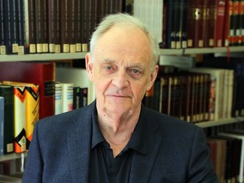
Tel.: +49 941 94354-34 lehmann@ios-regensburg.de
After completing his first MA in East European History and Slavic Language and Literature at Freie Universität Berlin, Hartmut Lehmann studied Economics and Statistics at the University of California, Berkeley, and the London School of Economics and Political Science, where he received his PhD with a thesis on “Labour Market Flows and Labour Market Policies in the British Isles, Eastern Germany and Poland.”
After completing his PhD, Lehmann first took up a position as head of the “Osteuropa” Department at the Leibniz Institute for Economic Research (ifo Institute), then as a lecturer in Economics at Trinity College Dublin, and Reader in Economics at Heriot-Watt University, Edinburgh. From 2003 to 2019, Lehmann held the Chair of Transformation Economics at the University of Bologna. From November 2019 to February 2022, he was leading research fellow for the Center for Labor Market Research at the Higher School of Economics (HSE University) in Moscow.
The focus of his research is on developments in the labor markets of transition countries, specifically Poland, Russia, and Ukraine. The topics of his research include the costs of job losses due to the restructuring of these economies, the evaluation of labor market policies, the development of informal employment in the post-Soviet space, effects of preferences and personality traits on the labor market and drivers of regional convergence.
Lehmann’s current additional posts include: Coordinator of the program “Labor Markets in Emerging Economies” at the IZA Institute of Labor Economics; member of the Editorial Board of the journal Economic Systems; Alma Mater Professor of Economics at the University of Bologna; and President of the European Association of Comparative Economics Studies (EACES).

